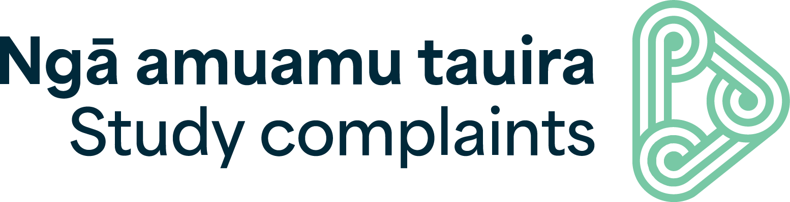
Study Complaints | Ngā Amuamu Tauira – 2026 Report summary

1 July 2025 to 30 June 2026

The logo on the top of the page is Study Complaints | Ngā Amuamu Tauira.

Welcome

Haere mai
Study Complaints | Ngā Amuamu Tauira is a free and independent dispute resolution service operated by Fair Way – kia tau. We help international students and domestic tertiary learners resolve financial and contractual complaints with New Zealand education providers. This report covers our second full year of operation, from 1 July 2025 to 30 June 2026.
This year 246 students used our service, evenly split with 51% domestic tertiary learners and 49% international students. This has increased by 18% from last year’s 208 enquiries. As in previous years, we saw peaks in enquiries at the beginning and end of academic terms, reflecting the pressures associated with enrolment processes, assessments, and examinations.
Refund requests remain the most common type of complaint we receive, and these are often combined with other issues. Within this category, we are seeing a growing number of complaints involving education agents. These matters raise important questions about the respective responsibilities and liabilities of providers and agents.
We had two matters on hand that each involved multiple complaints. One relating to the closure of a provider and the other relating to international students paying fees to an agent who did not pass the funds on to the host schools. These matters, with multiple claims from the same issues, have bumped up our case totals, as well as our cases on hand and average time per case.
Our focus is on resolving complaints early, with only 76 disputes progressing as formal claims. We take a consensual approach where possible, with 28% resolved through facilitation, while a further 21% reached agreement through mediation. The remaining 38% required an independent decision by an adjudicator.
We observed an increase in disputes that were already highly entrenched by the time they reached us, with some parties choosing to bypass consensual resolution methods and proceed directly to adjudication. In response, we have strengthened our adjudication process by introducing new internal guidance, a structured submission-builder tool, and an early case conference. Together, these enhancements contributed to a more timely, efficient, and consistent adjudication process.
Raising awareness and sharing insights also remains a key priority. Across the education sector, we have continued to promote best practice through presentations, events, and engagement activities. In particular, we have explored themes of fairness and reasonableness in decision-making, especially when applying discretionary policies. Our engagement with students has focused on improving accessibility and ensuring learners understand the support available to them throughout the complaints process.
Ngā mihi
Jeanie Robinson
Operations Manager - Commercial Services at Fairway Resolution Limited (Fair Way). As part of her role, Jeanie is responsible for Study Complaints | Ngā Amuamu Tauira.

2026 in review

How we helped
Our process is designed to empower students and education providers to resolve matters early and through consensual means where possible. Our aim is to meet the needs of learners studying in Aotearoa, ensuring they have a voice in the process and their mana, identity and wellbeing is prioritised. If a student and their education provider are unable to reach an agreed outcome, Study Complaints | Ngā Amuamu Tauira can provide finality through adjudication where a binding decision is issued.
Here is an overview of how we helped tauira from 1 July 2025 to 30 June 2026:

1. Get started
We find out more about you and arrange any support you may need.
- We received 246 enquiries
- 76 were accepted as claims
- In addition, we had 13 enquiries and 11 claims on hand carried over from last reporting year
- We resolved or closed 42 claims.

2. Facilitation & negotiation
We let your education provider know and get you talking.
- 12 claims were resolved through facilitation and negotiation.

3. Mediation
Collaborate and reach an agreement together at mediation.
- 9 claims reached an agreement at mediation
  - 89% resolved all matters
  - 11% resolved some matters.

4. Adjudication
We consider the dispute and make a decision during adjudication.
- 16 claims were adjudicated
  - 6% were upheld
  - 19% were partially upheld
  - 75% were not upheld.

Other
- 5 claims were withdrawn.

Overview of disputes
Enquiries overview
For the period of 1 July 2025 to 30 June 2026 a total of 246 enquiries were received. This increased by 18% from last year.
Of the total enquiries, 126 were domestic and 120 were international students.
In addition, 13 enquiries carried over from the previous reporting period, bringing our total to 259 enquiries on hand this year.

Progression of enquiries (combined – total 246)
- 29% of enquiries did not proceed or were withdrawn – this includes disputes that were resolved early between the learner and education provider
- 28% of enquiries were not accepted and determined as outside of jurisdiction
- 22% were accepted as claims – progressing to our dispute resolution process
- 11% remained on hand at the close of this period – under consideration by the team
- 5% were referred to other agencies or complaints bodies for further assistance
- 5% of enquiries were recorded as non-relevant – for example, requests for resources.
Nature of enquiries
The key categories this year were:
- 56% - Financial/contractual
- 24% - Other
- 20% - Refund.

Nature of enquiries (combined – total 246)
Nature of dispute | Domestic | International | Total
Compensation | 4 | 5 | 9
Contractual/Financial | 44 | 24 | 68
Financial difficulty | 2 |  | 2
General enquiry | 14 | 13 | 27
Misrepresentation |  | 1 | 1
Not SC Issue* | 12 | 11 | 23
Other (Not proceeding / withdrawn) |  | 1 | 1
Other (Contractual / financial) | 28 | 30 | 58
Refund - Course Closure | 2 |  | 2

Refund - Quality of Provision (Academic) | 1 | 1 | 2
Refund - Safety and Wellbeing | 3 | 4 | 7
Refund - Student support, advice and services | 6 | 2 | 8
Refund – Termination |  | 7 | 7
Refund - Visa declined |  | 4 | 4
Refund - Withdrawal | 10 | 17 | 27
Grand Total | 126 | 120 | 246

* Not within jurisdiction for Study Complaints | Ngā Amuamu Tauira.

Enquiries by provider type (combined – total 246)
Here is a breakdown of enquiries by education provider:
- 104 enquiries - PTEs
- 52 enquiries – University
- 48 enquiries – Polytechnic
- 20 enquiries – N/A
- 10 enquiries – Secondary school
- 7 enquiries – Wānanga
- 4 enquiries - Primary school
- 1 enquiry – Intermediate school
About provider types
Due to recent changes in the sector, in this report the Polytechnic category includes New Zealand Institute of Skills and Technology (NZIST), former Te Pūkenga, and with standalone polytechnics and institutes of technology.
N/A applies where the provider type is unknown or when the provider’s name has not been shared.

Claims overview
Within 10 working days of receiving an enquiry, we will either accept it as a claim, decline it, or ask for further information to help us decide whether we can accept it or not.

Of the 246 enquiries received during this reporting period, 76 were accepted as claims. An additional 11 claims were carried over from the previous reporting period.

Overview of claims accepted (combined - total 76)
Accepted claims | International | Domestic | Total
New claims accepted | 54 | 22 | 76
Brought forward  (ongoing claims from previous schemes) | 10 | 1 | 11
Total claims received | 64 | 23 | 87
Claims closed during period | 29 | 13 | 42
Claims remaining on hand | 31 | 11 | 42

Overview of how claims were resolved (combined - 42 total)
Method | Claims resolved
Facilitation / negotiation | 12
Mediation | 9
Adjudication | 16
Other | 5

Claims received by provider type (combined 76)
- 53 claims - PTEs
- 11 claim – Polytechnic
- 7 claims – University
- 3 claims – Secondary school
- 1 claim - Primary school
- 1 claim – Wānanga

Additional information
You can find a PDF of the full report here
If you have any questions, please get in touch with our team. You can contact us by:
- Free phone: 0800 00 66 75
- Email: help@studycomplaints.org.nz
- Web: www.studycomplaints.org.nz

End of Study Complaints | Ngā Amuamu Tauira 2026 Report summary

