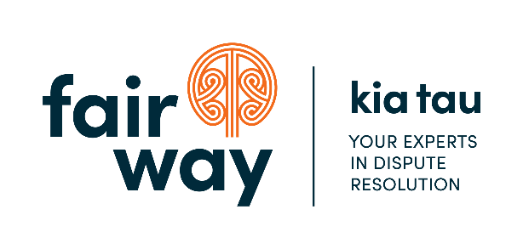
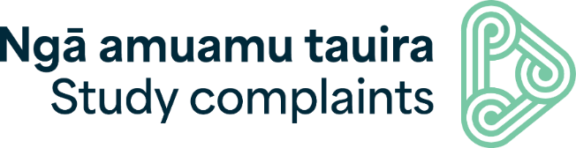

Fact sheet about

Study Complaints ⎜

Ngā Amuamu Tauira
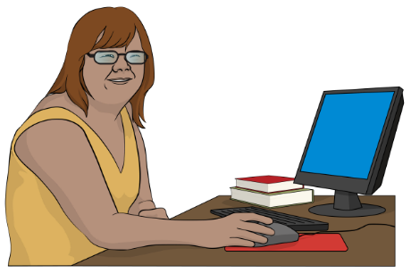

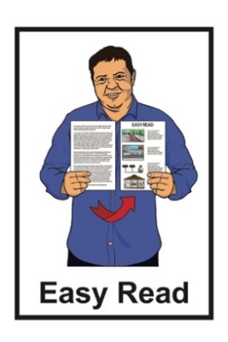
Published: April 2024

About
Study Complaints ⎜Ngā Amuamu Tauira

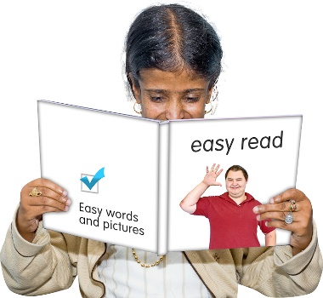
In this document:
Study Complaints ⎜Ngā Amuamu Tauira will be called Study Complaints
the word we means Study Complaints.

Study Complaints is a service that supports:
domestic tertiary students
international students.

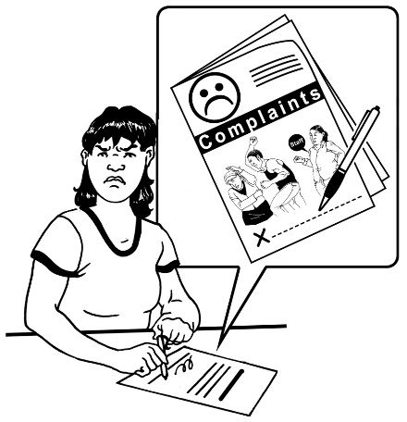
A complaint is telling someone:
there is a problem
something is wrong.

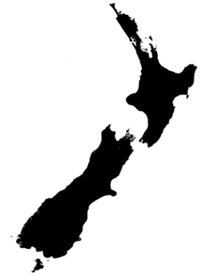
Domestic tertiary students are students from New Zealand:
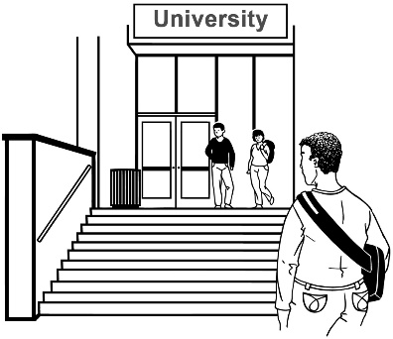
who study at places you go to after high school like:
- universities
- polytechnics.

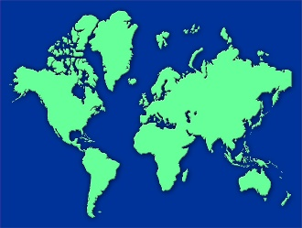
International students are students from other countries who have come to New Zealand to study at a:
- primary school level
- secondary school level
- tertiary level.

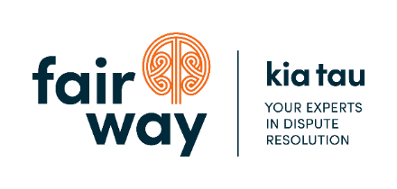
We are managed by Fair Way.

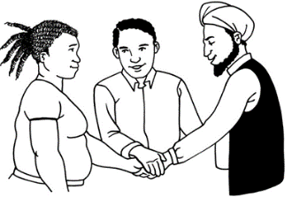
Fair Way:
is an experienced dispute resolution provider
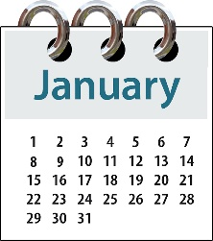
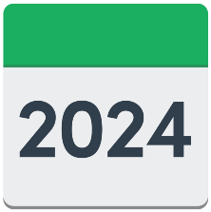
was appointed by the Ministry of Education to provide the Study Complaint service from
1 January 2024.
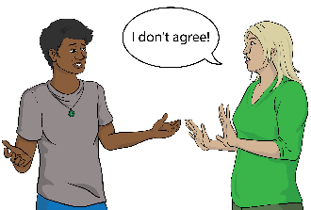

Disputes are disagreements.

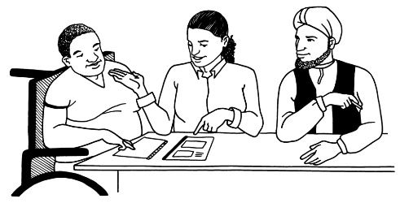
Dispute resolution is when people who disagree get support to sort things out together.

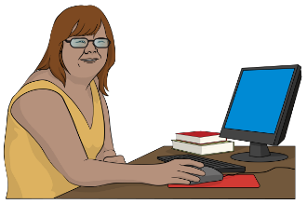
Our service is free for:
students
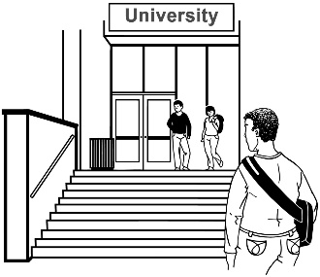
education providers like universities.

What we do

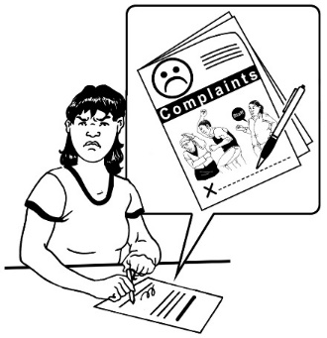
We work with students to help with any disputes they have with education providers in New Zealand.

We are:
free which means it will not cost you any money to ask us to assist you
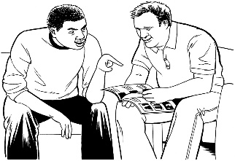
independent which means we are not connected to another group
here to assist.

We can assist with:
financial matters
contractual matters
redress claims.

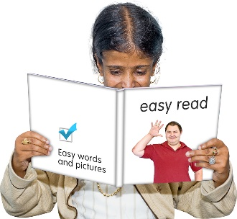
We will go through what each of these means on pages 8 to 10.

Things we do not assist with are:
students thinking the education they are getting is not good enough
complaints from domestic students who are in:
- primary school
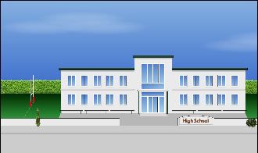
- secondary school like high school.

Financial matters

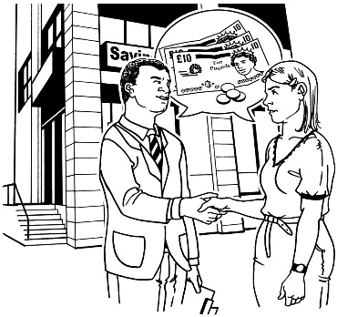
Financial matters are things to do with money like:
refunds which means wanting your money back
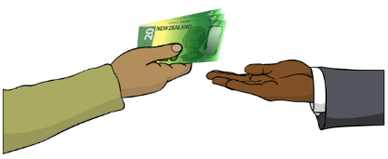
fees which means the money it costs to study.

Contractual matters

Contractual matters are things you have an agreement with your educational provider about like:
contracts to study
accommodation like if you are staying in student housing
changes to your study programme
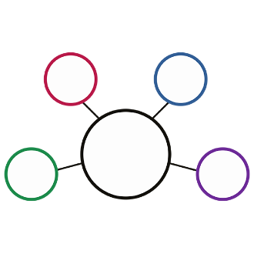
what happens when a programme you signed up for is no longer available.

Redress claims

Redress claims are when:
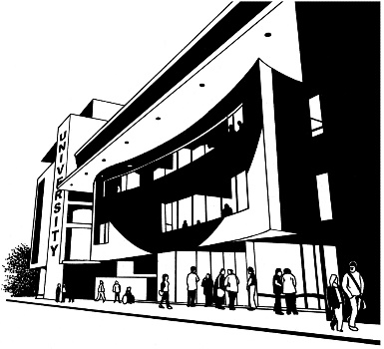
New Zealand Qualifications Authority / NZQA finds the place you study has not followed the Educational Code of Practice 2021.
you ask the place you study to make things right by:
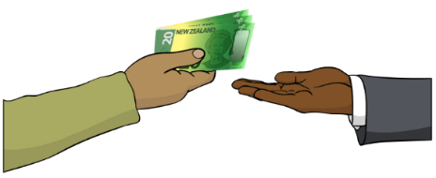
- paying you money
- doing something.

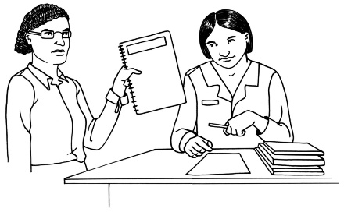
NZQA is an organisation that is part of the Government that makes sure everyone:
gets a good education
has records of their education.

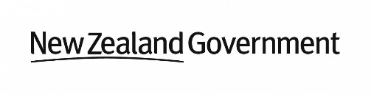
The Educational Code of Practice 2021 was started by the
New Zealand Government to make sure all tertiary education providers support their students well.

More information about NZQA can be found on their website:

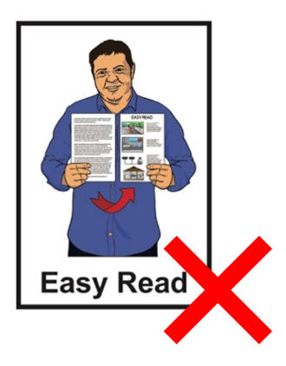
www.shorturl.at/pDW89

This information is not in Easy Read.

How Study Complaints can help you

If you have a problem with your education provider we can assist you to:
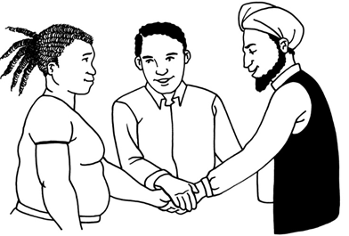
get to an agreement quickly
bring in someone who can support everyone to come to an agreement
make a decision if you can not make an agreement together.

How to contact us

You can contact us:
by phone:
0800 00 66 75
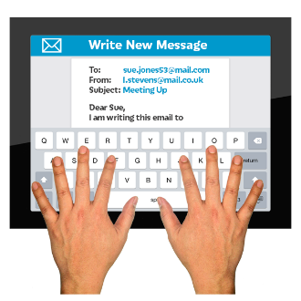
by email:
help@studycomplaints.org.nz
on our website:
www.studycomplaints.org.nz

If you find it hard to use the phone the New Zealand Relay service is for people who are:

- Deaf / hard of hearing

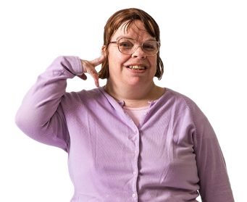
- deafblind

- speech impaired / find it hard to talk.

You can find out more about the
New Zealand Relay service at:

www.nzrelay.co.nz

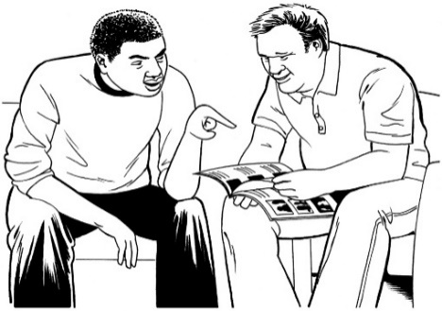
We will do our best to:
support you
guide you
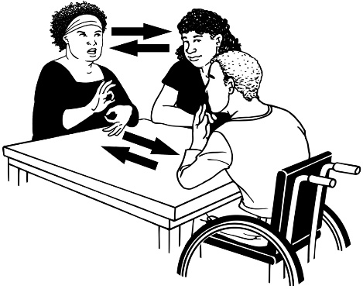
make everything as easy as possible for everyone.

Please let us know If you need any extra assistance like an interpreter.

More information

You can find out more about us on our website at:

www.studycomplaints.org.nz

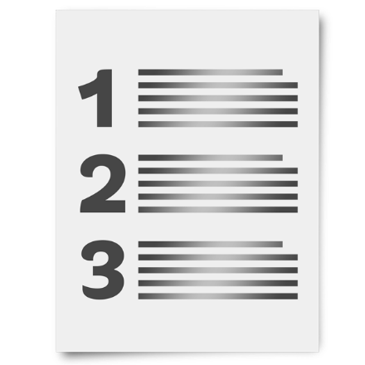
A list of questions we get asked a lot is available at this website:

www.shorturl.at/dEIOZ

This list is not in Easy Read.

Information in alternative formats is also available on our website at:
www.shorturl.at/jBIKU

This information has been written by Fair Way Resolution Limited.

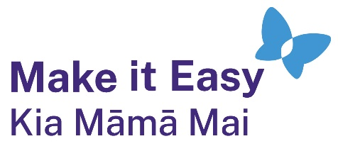
It has been translated into Easy Read by the Make it Easy Kia Māmā Mai service of People First New Zealand Ngā Tāngata Tuatahi.
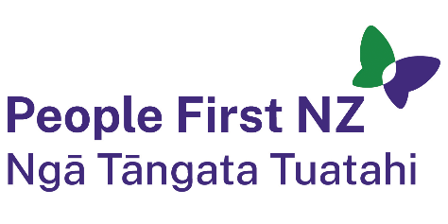
The ideas in this document are not the ideas of People First New Zealand Ngā Tāngata Tuatahi.
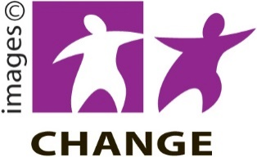
Make it Easy uses images from:
- Changepeople.org
            - Photosymbols.com
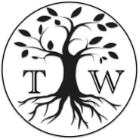
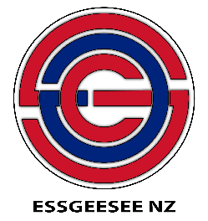
- SGC Image Works
- Huriana Kopeke-Te Aho
- T. Wood.
All images used in this Easy Read document are subject to copyright rules and cannot be used without permission.

